## Confirming the DNS Configuration for SCAN

10.68.26.246 SAND2-EW-SCAN

10.68.26.247 SAND2-EW-SCAN

10.68.26.248 SAND2-EW-SCAN

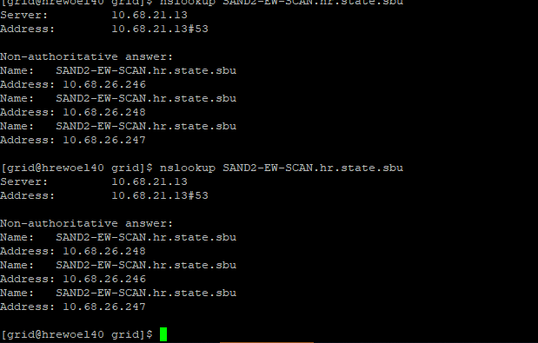

**IP Name and Address Requirements for Manual Configuration of Cluster**

10.68.26.191 hrewoel40.hr.state.sbu hrewoel40

10.68.26.202 hrewoel40-vip

192.168.10.71 hrewoel40-priv1

192.168.20.71 hrewoel40-priv2

192.168.155.241 hrewoel40-sl

10.68.26.192 hrewoel41.hr.state.sbu hrewoel41

10.68.26.203 hrewoel41-vip

192.168.10.72 hrewoel41-priv1

192.168.20.72 hrewoel41-priv2

192.168.155.242 hrewoel41-sl

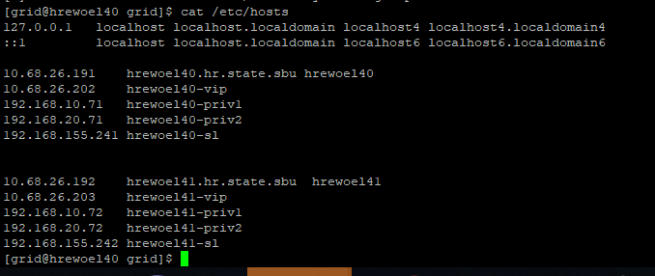

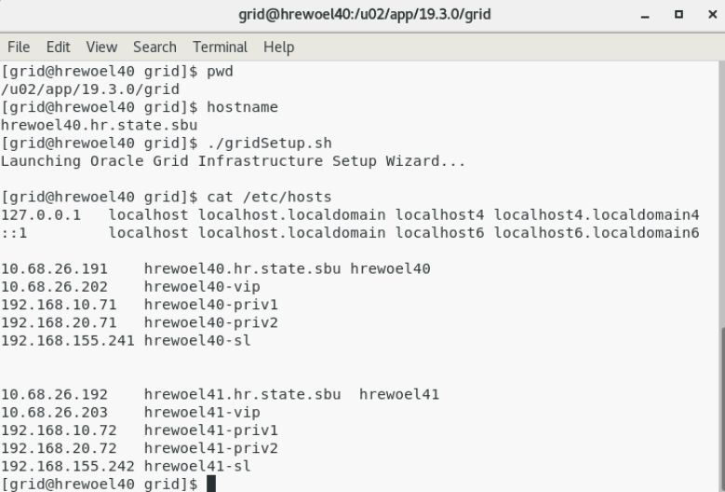

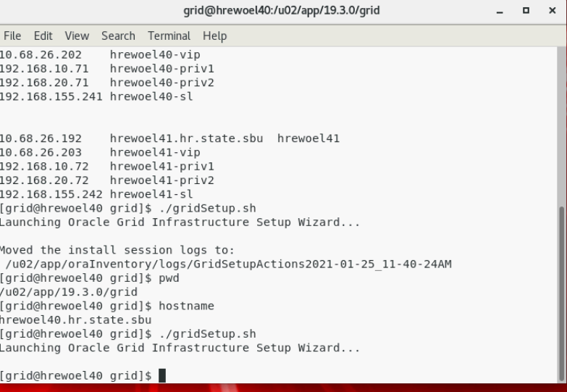

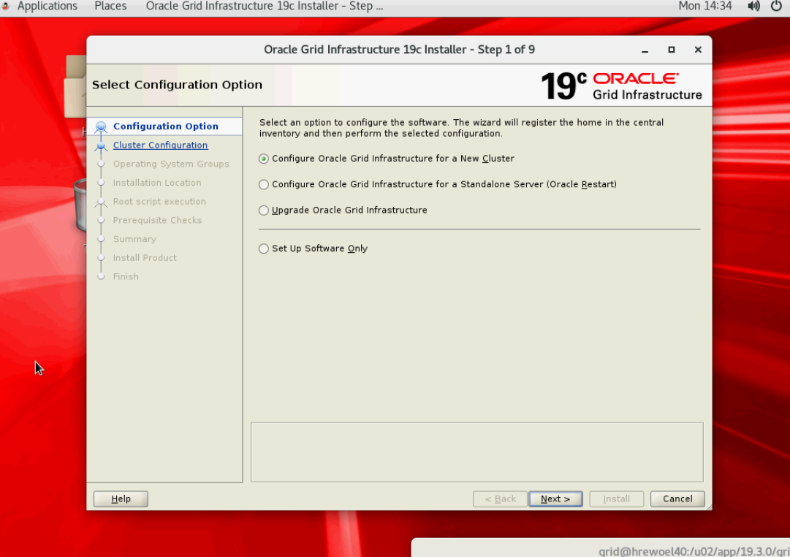

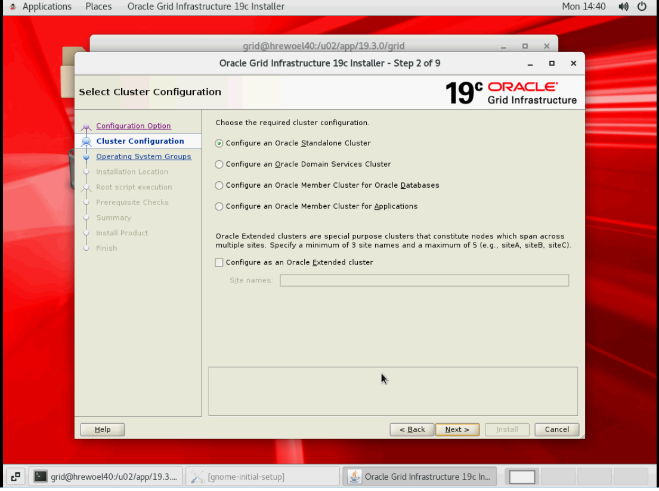

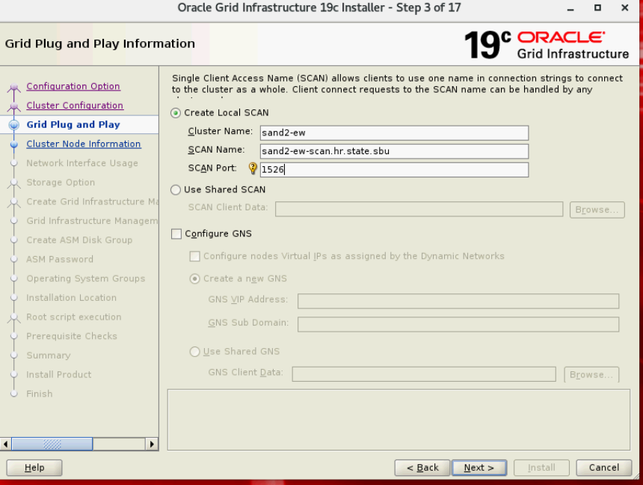

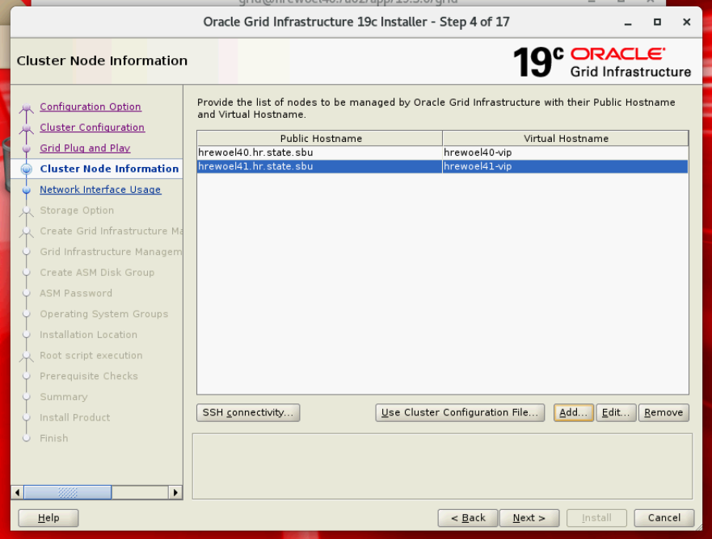

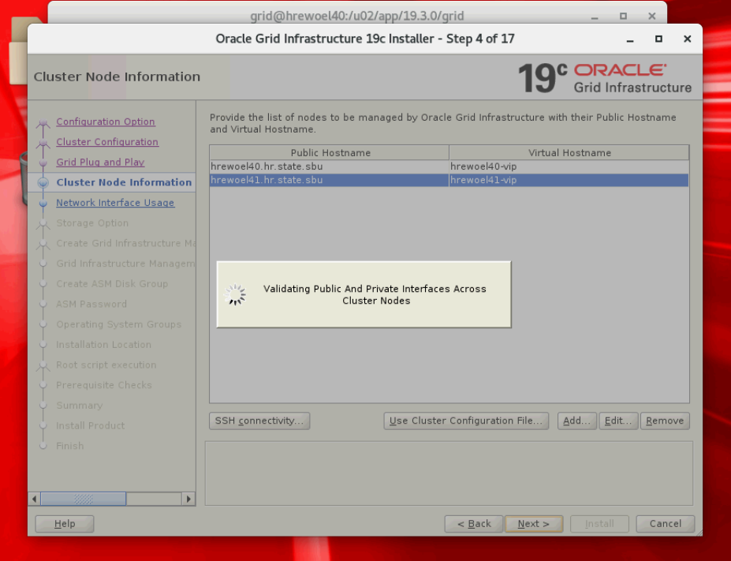

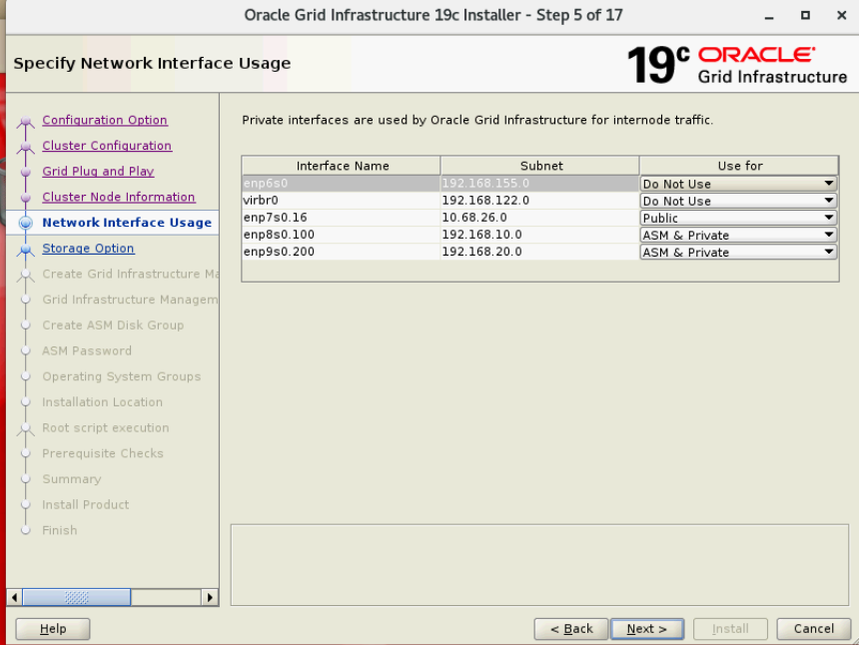

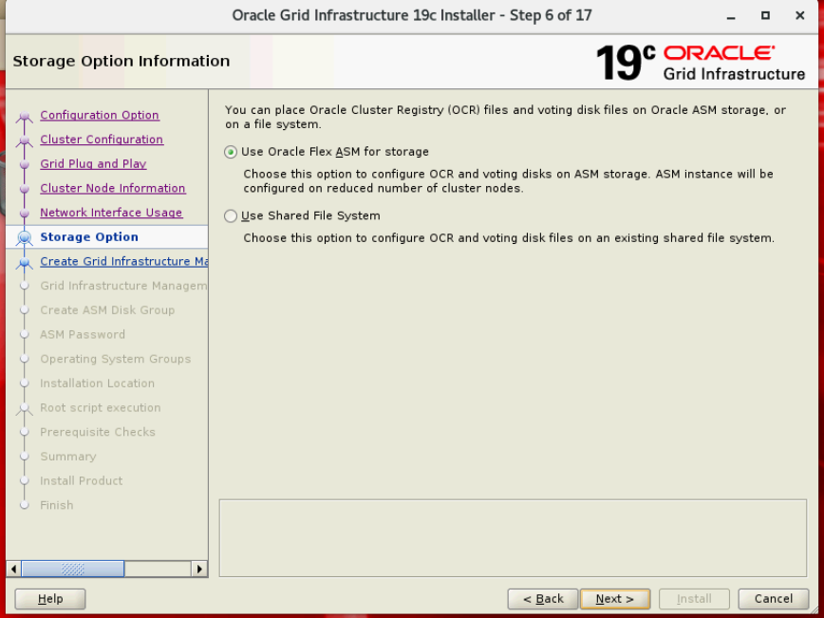

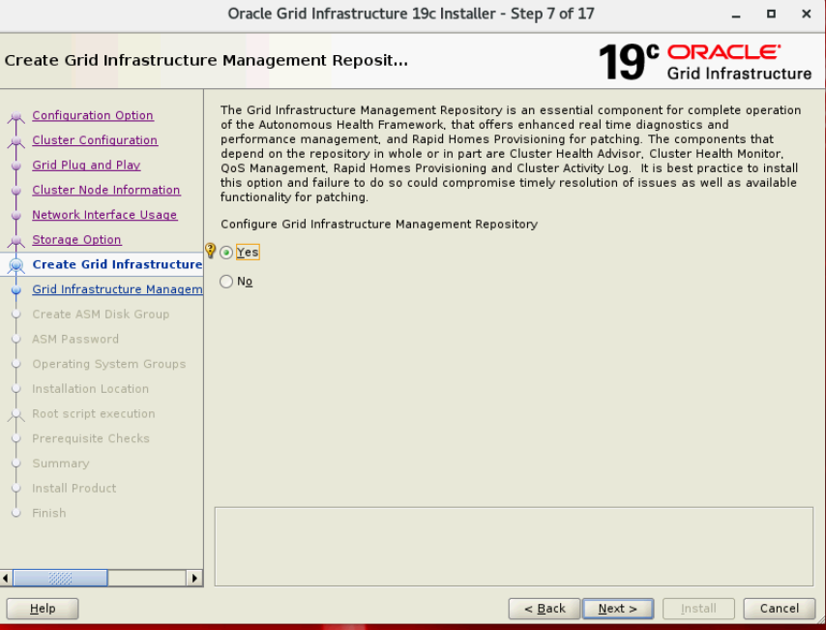

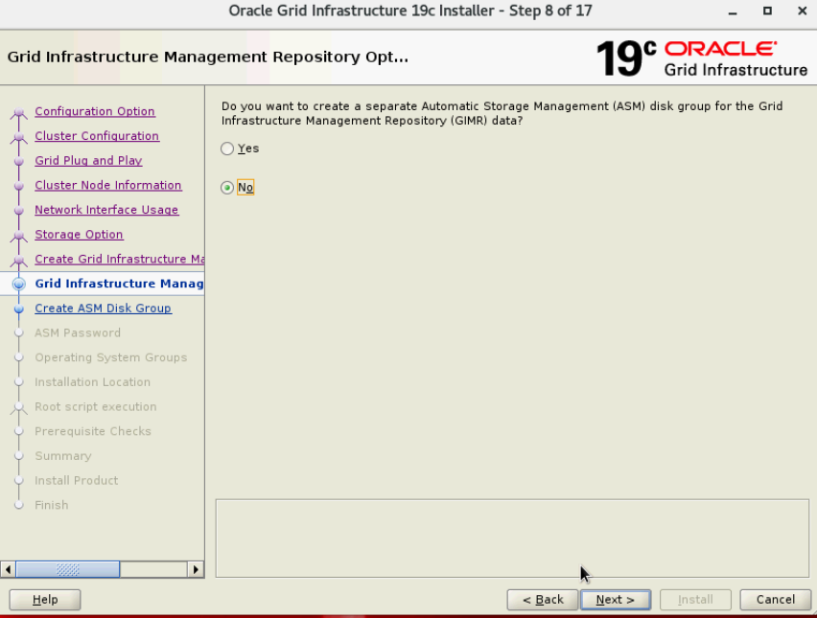

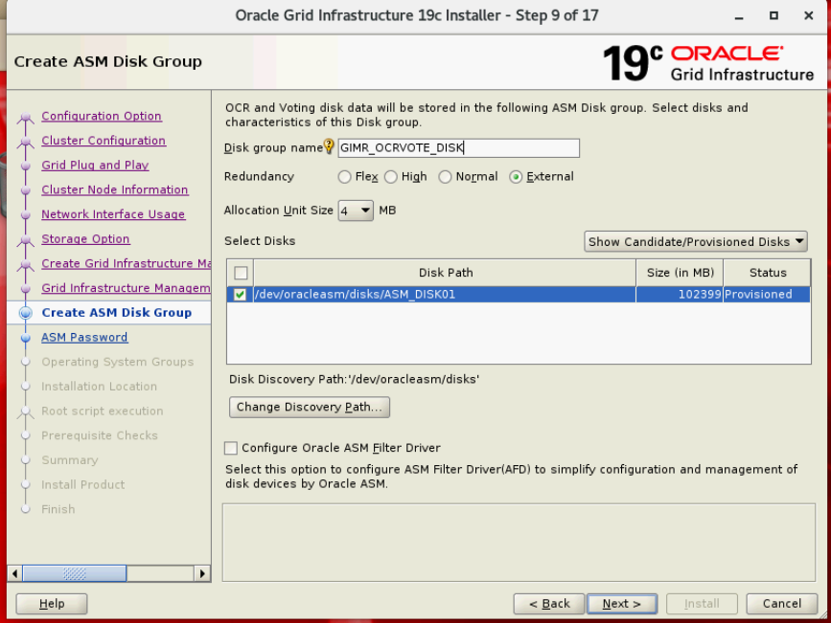

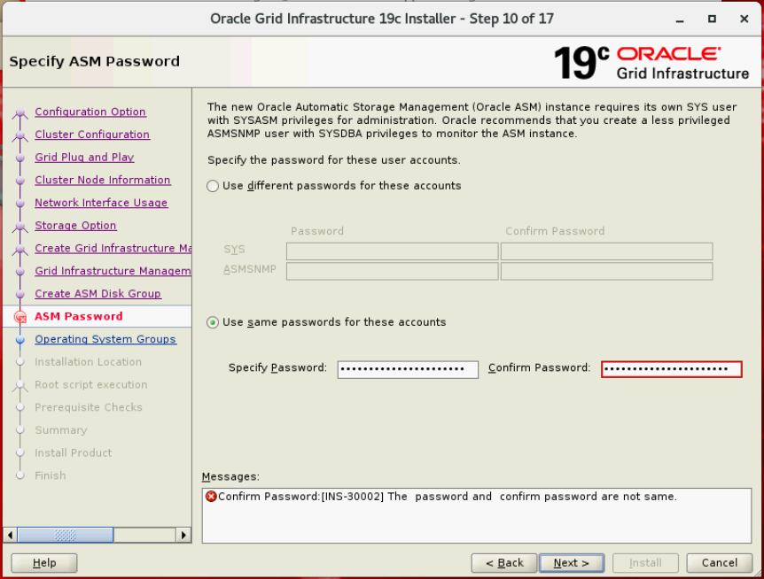

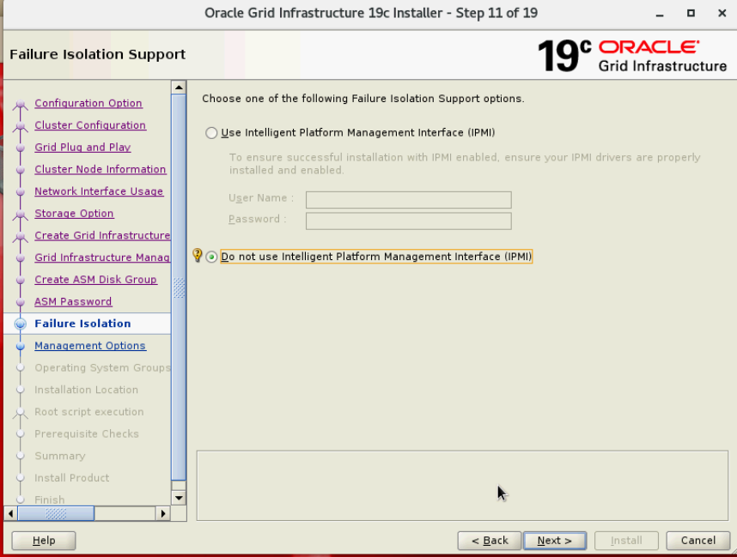

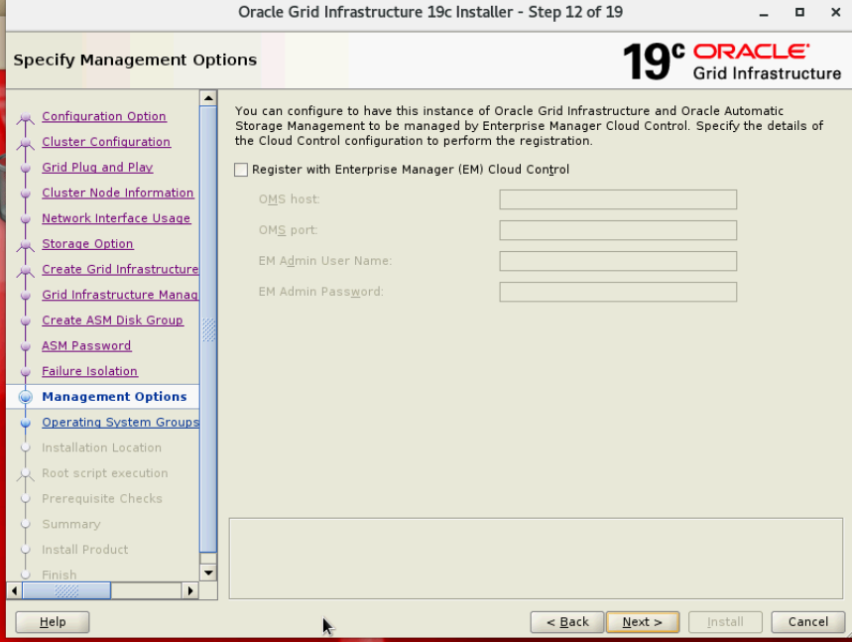

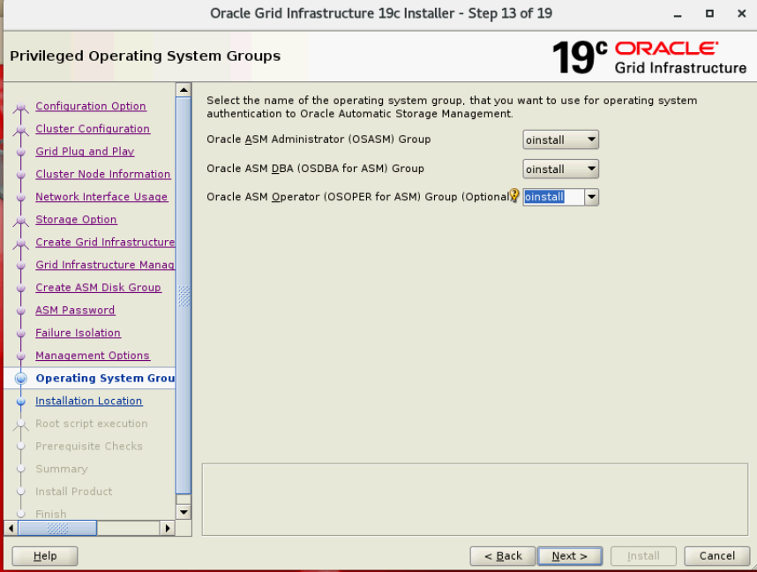

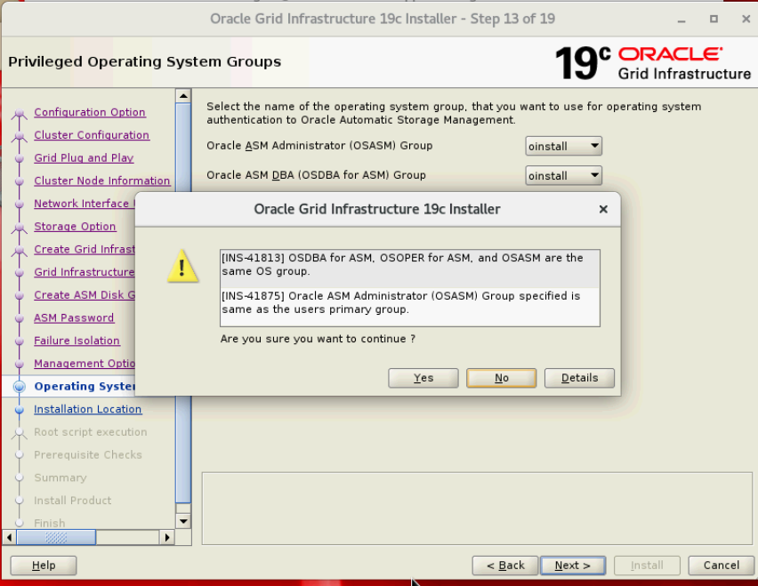

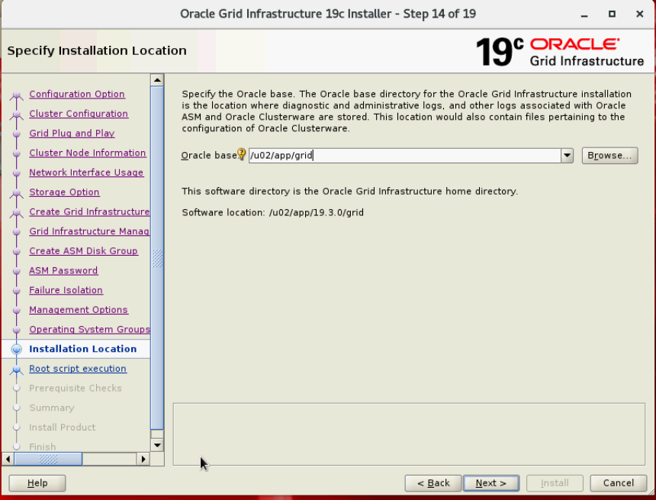

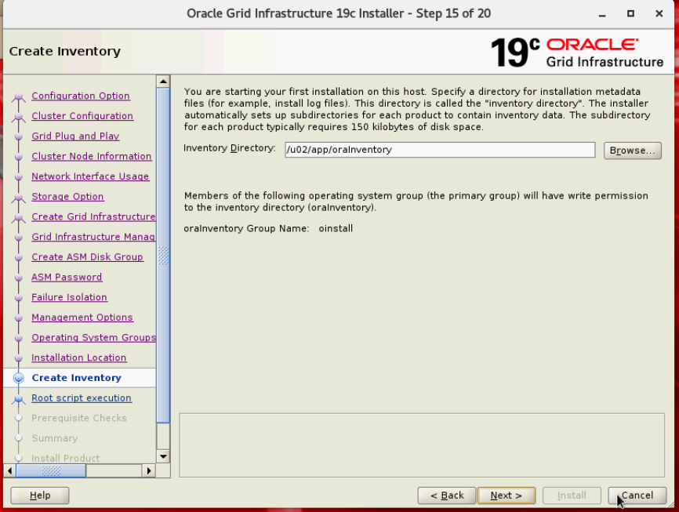

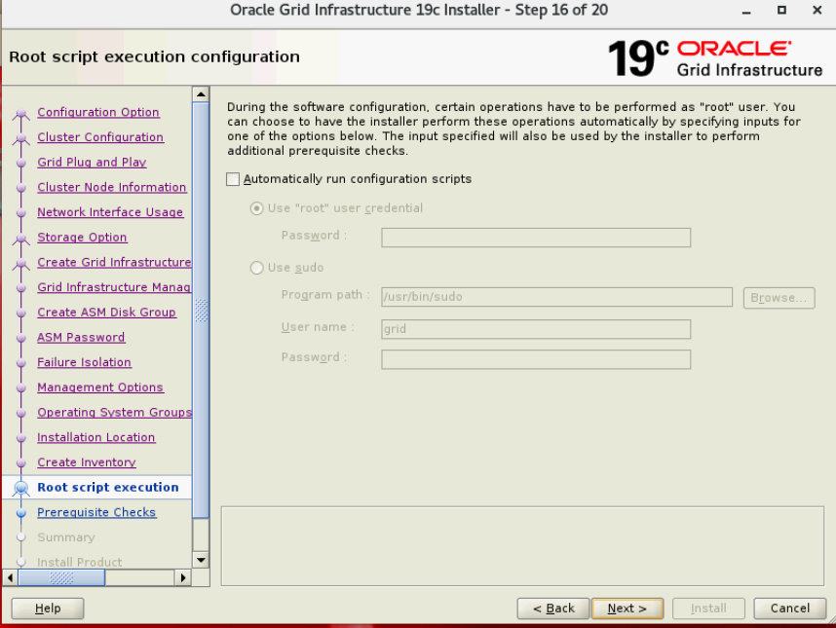

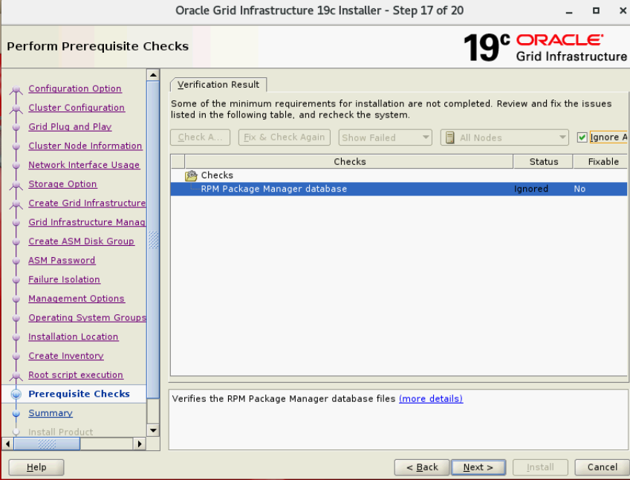

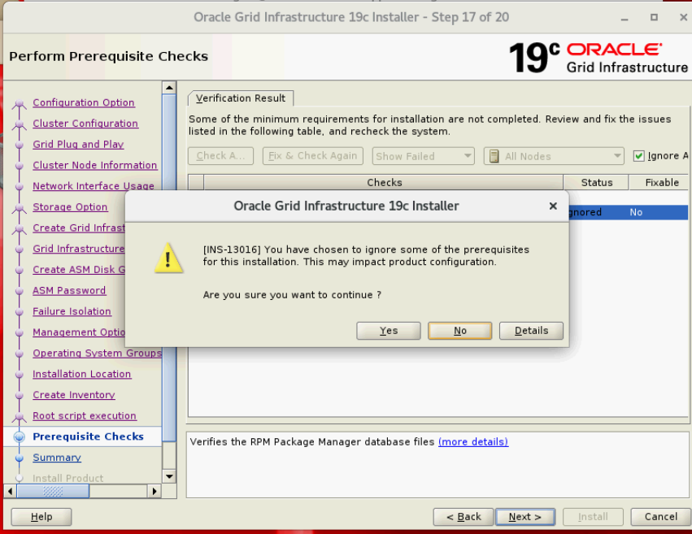

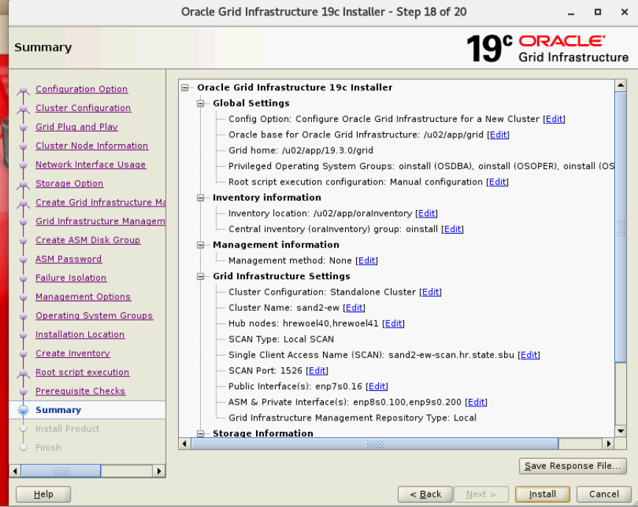

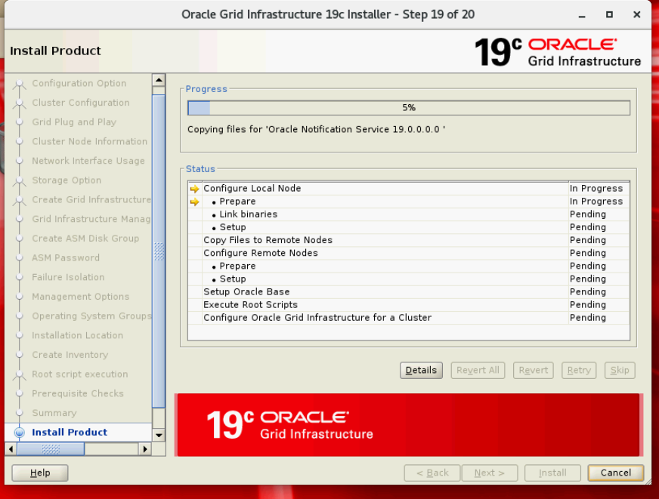

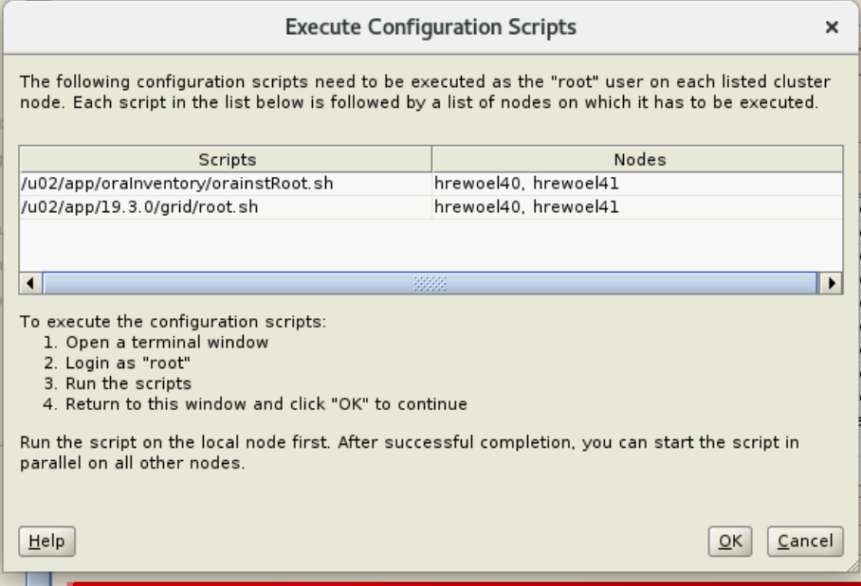

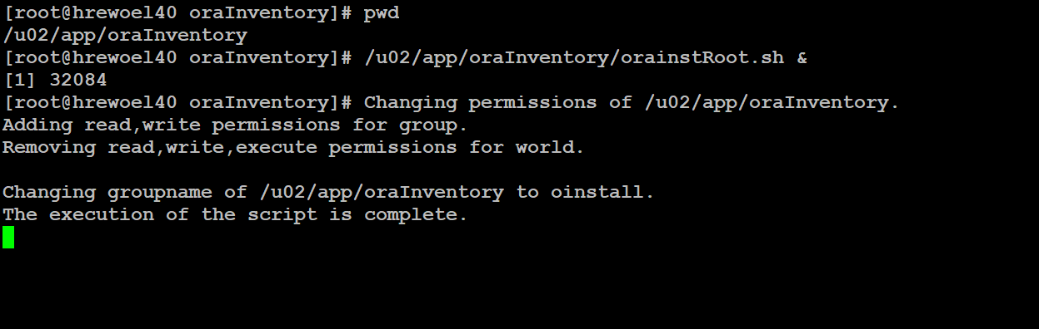

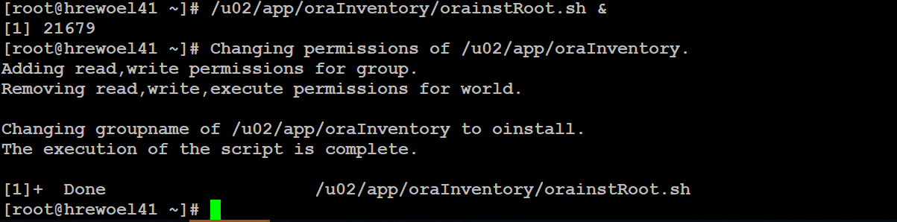

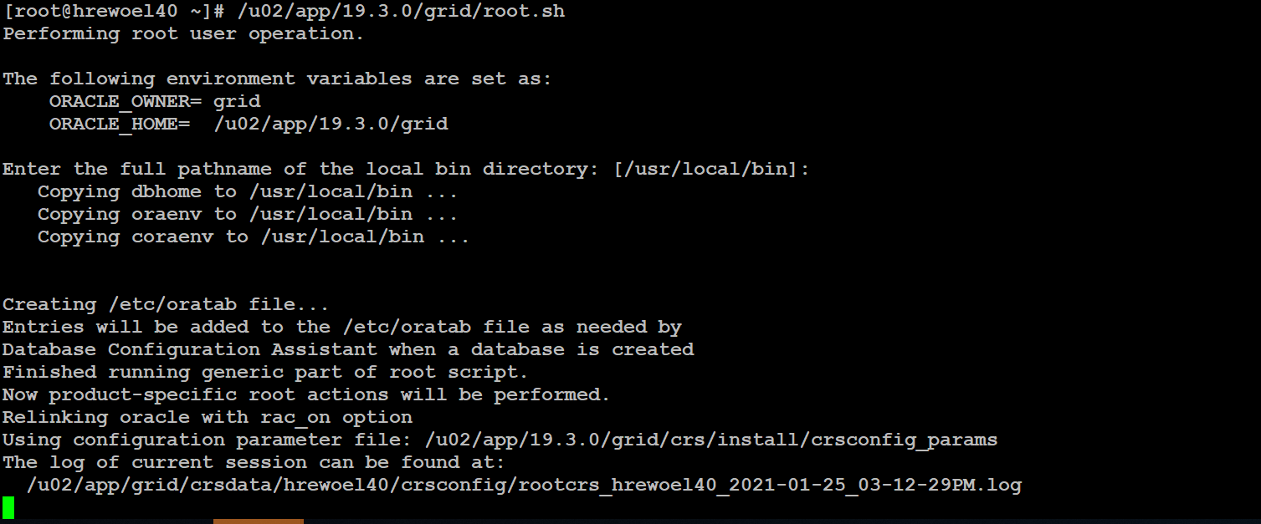

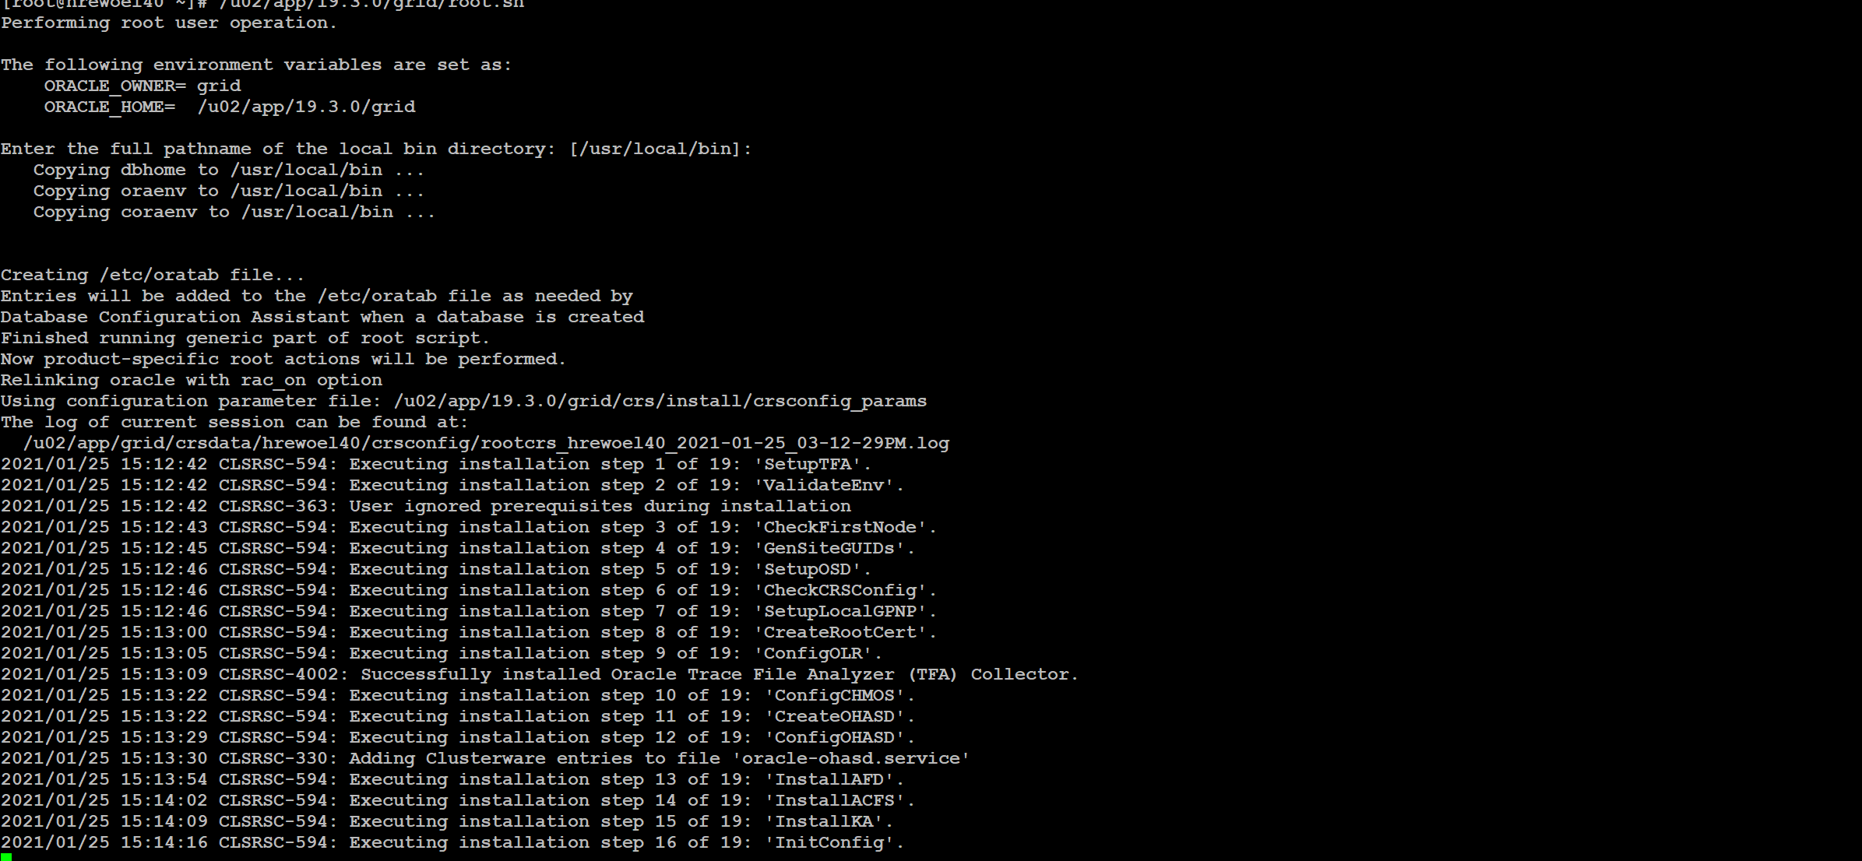

[root@hrewoel40 ~]# /u02/app/19.3.0/grid/root.sh

Performing root user operation.

The following environment variables are set as:

ORACLE_OWNER= grid

ORACLE_HOME= /u02/app/19.3.0/grid

Enter the full pathname of the local bin directory: [/usr/local/bin]:

Copying dbhome to /usr/local/bin ...

Copying oraenv to /usr/local/bin ...

Copying coraenv to /usr/local/bin ...

Creating /etc/oratab file...

Entries will be added to the /etc/oratab file as needed by

Database Configuration Assistant when a database is created

Finished running generic part of root script.

Now product-specific root actions will be performed.

Relinking oracle with rac_on option

Using configuration parameter file: /u02/app/19.3.0/grid/crs/install/crsconfig_params

The log of current session can be found at:

/u02/app/grid/crsdata/hrewoel40/crsconfig/rootcrs_hrewoel40_2021-01-25_03-12-29PM.log

2021/01/25 15:12:42 CLSRSC-594: Executing installation step 1 of 19: 'SetupTFA'.

2021/01/25 15:12:42 CLSRSC-594: Executing installation step 2 of 19: 'ValidateEnv'.

2021/01/25 15:12:42 CLSRSC-363: User ignored prerequisites during installation

2021/01/25 15:12:43 CLSRSC-594: Executing installation step 3 of 19: 'CheckFirstNode'.

2021/01/25 15:12:45 CLSRSC-594: Executing installation step 4 of 19: 'GenSiteGUIDs'.

2021/01/25 15:12:46 CLSRSC-594: Executing installation step 5 of 19: 'SetupOSD'.

2021/01/25 15:12:46 CLSRSC-594: Executing installation step 6 of 19: 'CheckCRSConfig'.

2021/01/25 15:12:46 CLSRSC-594: Executing installation step 7 of 19: 'SetupLocalGPNP'.

2021/01/25 15:13:00 CLSRSC-594: Executing installation step 8 of 19: 'CreateRootCert'.

2021/01/25 15:13:05 CLSRSC-594: Executing installation step 9 of 19: 'ConfigOLR'.

2021/01/25 15:13:09 CLSRSC-4002: Successfully installed Oracle Trace File Analyzer (TFA) Collector.

2021/01/25 15:13:22 CLSRSC-594: Executing installation step 10 of 19: 'ConfigCHMOS'.

2021/01/25 15:13:22 CLSRSC-594: Executing installation step 11 of 19: 'CreateOHASD'.

2021/01/25 15:13:29 CLSRSC-594: Executing installation step 12 of 19: 'ConfigOHASD'.

2021/01/25 15:13:30 CLSRSC-330: Adding Clusterware entries to file 'oracle-ohasd.service'

2021/01/25 15:13:54 CLSRSC-594: Executing installation step 13 of 19: 'InstallAFD'.

2021/01/25 15:14:02 CLSRSC-594: Executing installation step 14 of 19: 'InstallACFS'.

2021/01/25 15:14:09 CLSRSC-594: Executing installation step 15 of 19: 'InstallKA'.

2021/01/25 15:14:16 CLSRSC-594: Executing installation step 16 of 19: 'InitConfig'.

ASM has been created and started successfully.

[DBT-30001] Disk groups created successfully. Check /u02/app/grid/cfgtoollogs/asmca/asmca-210125PM031449.log for details.

2021/01/25 15:15:47 CLSRSC-482: Running command: '/u02/app/19.3.0/grid/bin/ocrconfig -upgrade grid oinstall'

CRS-4256: Updating the profile

Successful addition of voting disk d5261f148e8c4f4fbfff461f50f8afbf.

Successfully replaced voting disk group with +GIMR_OCRVOTE_DISK.

CRS-4256: Updating the profile

CRS-4266: Voting file(s) successfully replaced

## STATE File Universal Id File Name Disk group

-- ----- ----------------- --------- ---------

1. ONLINE d5261f148e8c4f4fbfff461f50f8afbf (/dev/oracleasm/disks/ASM_DISK01) [GIMR_OCRVOTE_DISK]

Located 1 voting disk(s).

2021/01/25 15:17:17 CLSRSC-594: Executing installation step 17 of 19: 'StartCluster'.

2021/01/25 15:18:25 CLSRSC-343: Successfully started Oracle Clusterware stack

2021/01/25 15:18:25 CLSRSC-594: Executing installation step 18 of 19: 'ConfigNode'.

2021/01/25 15:20:00 CLSRSC-594: Executing installation step 19 of 19: 'PostConfig'.

2021/01/25 15:20:26 CLSRSC-325: Configure Oracle Grid Infrastructure for a Cluster ... succeeded

[root@hrewoel40 ~]#

[root@hrewoel40 ~]#

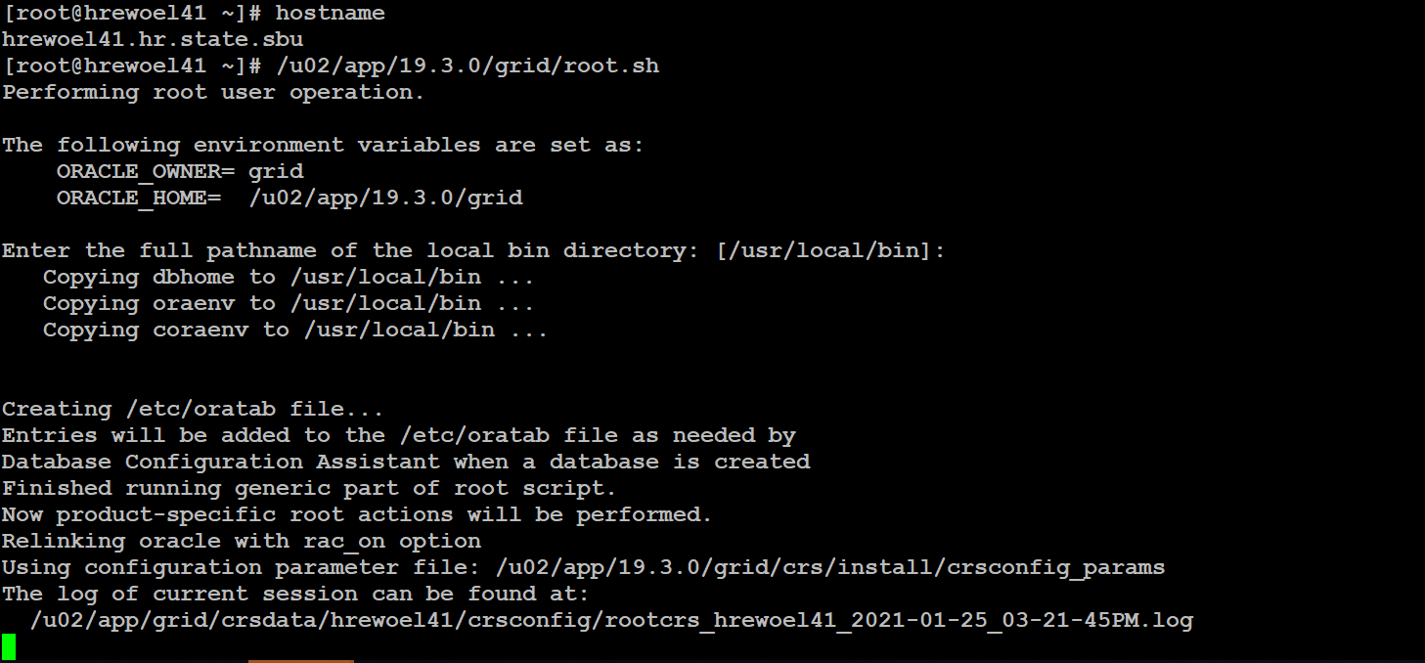

hrewoel41.hr.state.sbu

[root@hrewoel41 ~]# /u02/app/19.3.0/grid/root.sh

Performing root user operation.

The following environment variables are set as:

ORACLE_OWNER= grid

ORACLE_HOME= /u02/app/19.3.0/grid

Enter the full pathname of the local bin directory: [/usr/local/bin]:

The contents of "dbhome" have not changed. No need to overwrite.

The contents of "oraenv" have not changed. No need to overwrite.

The contents of "coraenv" have not changed. No need to overwrite.

Entries will be added to the /etc/oratab file as needed by

Database Configuration Assistant when a database is created

Finished running generic part of root script.

Now product-specific root actions will be performed.

Relinking oracle with rac_on option

Using configuration parameter file: /u02/app/19.3.0/grid/crs/install/crsconfig_params

The log of current session can be found at:

/u02/app/grid/crsdata/hrewoel41/crsconfig/rootcrs_hrewoel41_2021-01-25_03-52-19PM.log

2021/01/25 15:52:26 CLSRSC-594: Executing installation step 1 of 19: 'SetupTFA'.

2021/01/25 15:52:26 CLSRSC-594: Executing installation step 2 of 19: 'ValidateEnv'.

2021/01/25 15:52:26 CLSRSC-363: User ignored prerequisites during installation

2021/01/25 15:52:26 CLSRSC-594: Executing installation step 3 of 19: 'CheckFirstNode'.

2021/01/25 15:52:27 CLSRSC-4002: Successfully installed Oracle Trace File Analyzer (TFA) Collector.

2021/01/25 15:52:28 CLSRSC-594: Executing installation step 4 of 19: 'GenSiteGUIDs'.

2021/01/25 15:52:28 CLSRSC-594: Executing installation step 5 of 19: 'SetupOSD'.

2021/01/25 15:52:28 CLSRSC-594: Executing installation step 6 of 19: 'CheckCRSConfig'.

2021/01/25 15:52:29 CLSRSC-594: Executing installation step 7 of 19: 'SetupLocalGPNP'.

2021/01/25 15:52:29 CLSRSC-594: Executing installation step 8 of 19: 'CreateRootCert'.

2021/01/25 15:52:30 CLSRSC-594: Executing installation step 9 of 19: 'ConfigOLR'.

2021/01/25 15:52:30 CLSRSC-594: Executing installation step 10 of 19: 'ConfigCHMOS'.

2021/01/25 15:53:01 CLSRSC-594: Executing installation step 11 of 19: 'CreateOHASD'.

2021/01/25 15:53:02 CLSRSC-594: Executing installation step 12 of 19: 'ConfigOHASD'.

2021/01/25 15:53:05 CLSRSC-594: Executing installation step 13 of 19: 'InstallAFD'.

2021/01/25 15:53:05 CLSRSC-594: Executing installation step 14 of 19: 'InstallACFS'.

2021/01/25 15:53:07 CLSRSC-594: Executing installation step 15 of 19: 'InstallKA'.

2021/01/25 15:53:08 CLSRSC-594: Executing installation step 16 of 19: 'InitConfig'.

2021/01/25 15:53:12 CLSRSC-594: Executing installation step 17 of 19: 'StartCluster'.

2021/01/25 15:54:22 CLSRSC-343: Successfully started Oracle Clusterware stack

2021/01/25 15:54:22 CLSRSC-594: Executing installation step 18 of 19: 'ConfigNode'.

2021/01/25 15:54:34 CLSRSC-594: Executing installation step 19 of 19: 'PostConfig'.

2021/01/25 15:54:42 CLSRSC-325: Configure Oracle Grid Infrastructure for a Cluster ... succeeded

[root@hrewoel41 ~]#

